**Name: G. Bhuvana Chandrika**

**Trainer Name: Harshee Pitroda**

**Course Name: Python & machine Learning Basics**

**Date:03/06/2022**

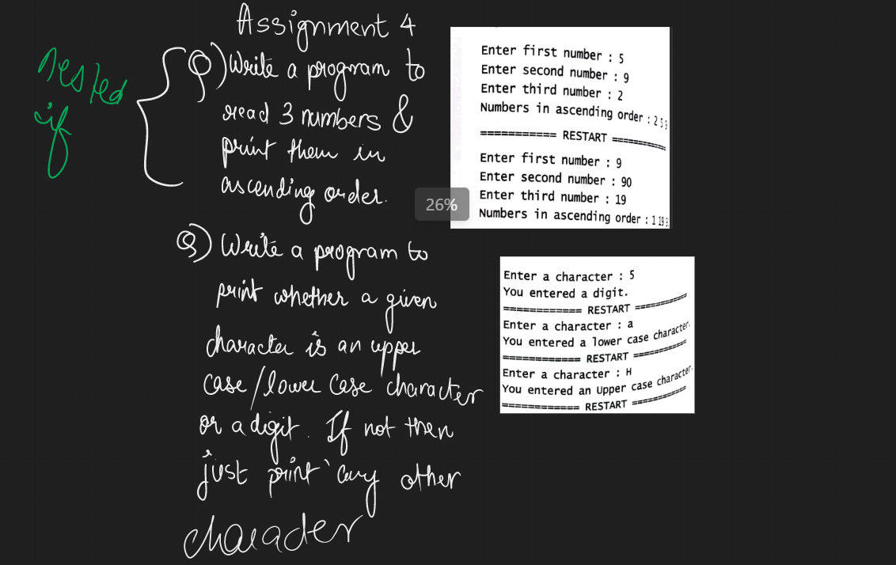

1)

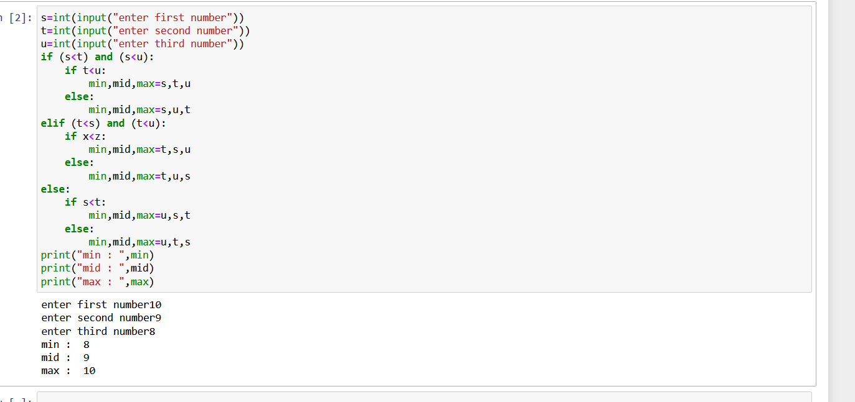

2)

